Roll no: 717822P128

Name: Krisha C S

Task1

Write a simple script that displays “Hello, World!” on the web page using an alert box.

<html>

<head>

<title>task</title>

</head>

<body>

<script>

alert("Hello World");

</script>

</body>

</html>

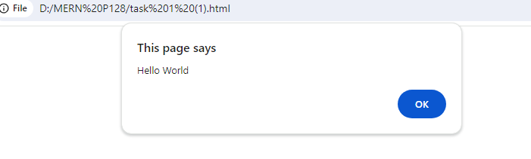

Task 2:

Experiment with different data types in JavaScript (e.g., string, number, boolean) by declaring and logging them in the console.

<html>

<head>

<title>task2</title>

</head>

<body>

<script>

var number = 28;

var string = "Krisha";

var boolean= true;

console.log(number);

console.log(string);

console.log(boolean);

</script>

</body>

</html>

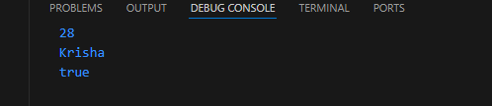

Task 3:

Use the console to perform basic math operations like addition, subtraction, multiplication, and division.

<html>

<head>

<title>Task 3</title>

</head>

<body>

<script>

console.log("Addition:",22+1);

console.log("Subtraction:",100-25);

console.log("Multiplication:",4\*5);

console.log("Division:",225/5);

</script>

</body>

</html>

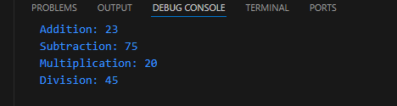

Task 4:

Declare two strings and concatenate them using the + operator.

<html>

<head>

<title>task 4</title>

</head>

<body>

<script>

var string1 = "Hello";

var string2 = "World";

console.log(string1+string2);

</script>

</body>

</html>

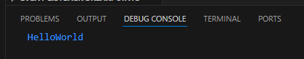

Task 5:

Use the typeof operator to check the data type of various variables.

<html>

<head>

<title>Task 5</title>

</head>

<body>

<script>

var name= "Krisha";

var rollno = 28;

var compare= 22>25;

console.log(typeof name);

console.log(typeof rollno);

console.log(typeof compare);

</script>

</body>

</html>

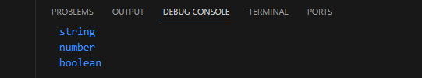

Task 6:

Write a multi-line JavaScript comment and a single-line comment. Explain the difference.

<html>

<head>

<title>Task 6</title>

</head>

<body>

<script>

var no= 25; //A number is assigned.

var no2= 20;

console.log(no+no2);

/\* The two numbers are added \*/

</script>

</body>

</html>



Single Line Comments

* Single line comments start with //.
* Any text between // and the end of the line will be ignored by JavaScript (will not be executed).

Multi-line Comments

* Multi-line comments start with /\* and end with \*/.
* Any text between /\* and \*/ will be ignored by JavaScript.

Task 7:

Create a script with both semicolon-separated and not separated lines. Note any differences in behavior.

<html>

<head>

<Title>task 8</Title>

</head>

<body>

<script>

var name = "krisha"

var no= 28;

console.log(name)

console.log(no);

</script>

</body>

</html>

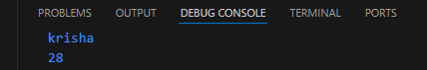

Task 8:

Use proper indentation to format a nested loop

<html>

<head>

<title>task 8</title>

</head>

<body>

<script>

for(var i=0;i<5;i++){

console.log(i);

}

</script>

</body>

</html>

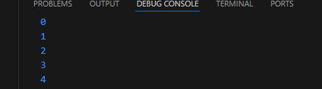

Task 9:

Declare multiple variables in a single line.

<html>

<head>

<title>task 9</title>

</head>

<body>

<script>

var name= "Krisha", rollno= 28;

console.log(name, rollno);

</script>

</body>

</html>



Task 10:

Place a script tag at the top and bottom of an HTML document. Note any differences in behavior

<script>

console.log("Script tag at the top");

</script>

<html>

<head>

<title>Task 10</title>

</head>

<body>

<script>

console.log("Script tag at the bottom");

</script>

</body>

</html>

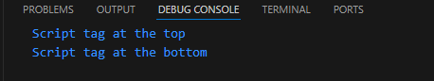

Task 11:

Write a script without using “use strict” and try to assign a value to an undeclared variable. Note the result.

<html>

<head>

<title>Task 11</title>

</head>

<body>

<script>

let name;

name= 'Krisha';

console.log(name);

</script>

</body>

</html>

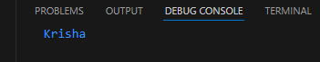

Task 12:

Enable “use strict” mode and repeat the above action, noting the difference.

<html>

<head>

<title>Task 12</title>

</head>

<body>

<script>

"Use strict";

let name;

name= 'Krisha';

console.log(name);

</script>

</body>

</html>

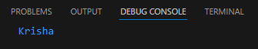

Task 13:

In “use strict” mode, try to delete a variable, function, or function parameter.

<html>

<head>

<title>Task 12</title>

</head>

<body>

<script>

"Use strict"

let name;

name= 'Krisha';

delete name;

console.log(name);

</script>

</body>

</html>



Task 14:

Assign a value to an undeclared variable without “use strict” and then with “use strict”.

<html>

<head>

<title>Task 11</title>

</head>

<body>

<script>

let name;

name= 'Krisha';

console.log(name);

</script>

</body>

</html>



<html>

<head>

<title>Task 12</title>

</head>

<body>

<script>

"Use strict";

let name;

name= 'Krisha';

console.log(name);

</script>

</body>

</html>



Task 15:

Declare a variable with a reserved keyword in “use strict” mode.

<html>

<head>

<title>Task 15</title>

</head>

<body>

<script>

"Use strict";

let case = 10

console.log(case);

</script>

</body>

</html>

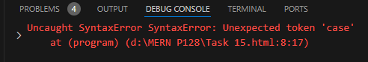

Task 16:

Declare variables using let, const, and var. Discuss when each should be used.

<html>

<head>

<title>Task 16</title>

</head>

<body>

<script>

let name = "Krisha";

var id = 100;

const rollno = 128;

console.log(name);

console.log(id);

console.log(rollno);

</script>

</body>

</html>

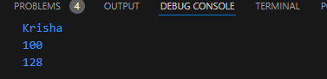

Task 17:

Attempt to reassign a const variable and observe the result

<html>

<head>

<title>Task 18</title>

</head>

<body>

<script>

const no = 100;

no = 20;

console.log(no);

</script>

</body>

</html>

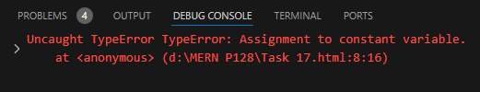

Task 18:

Declare a variable without initializing it and print its value.

<html>

<head>

<title>Task 18</title>

</head>

<body>

<script>

let name;

console.log(name);

</script>

</body>

</html>

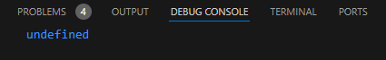

Task 19:

Assign a number, string, and boolean value to a variable and print its type using typeof.

<html>

<head>

<title>task 19</title>

</head>

<body>

<script>

var rollno = 28;

var name = "Krisha";

var state= true;

console.log(typeof(rollno));

console.log(typeof(name));

console.log(typeof(state));

</script>

</body>

</html>

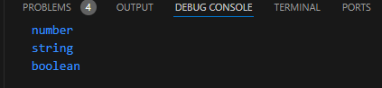

Task 20:

Rename a variable and observe the outcome.

<html>

<head>

<title>Task 20</title>

</head>

<body>

<script>

let num = 28;

num1 = num;

console.log(num1);

</script>

</body>

</html>

